

Aurora Orchard Manor Transition Service
Statement of Purpose
November 2024

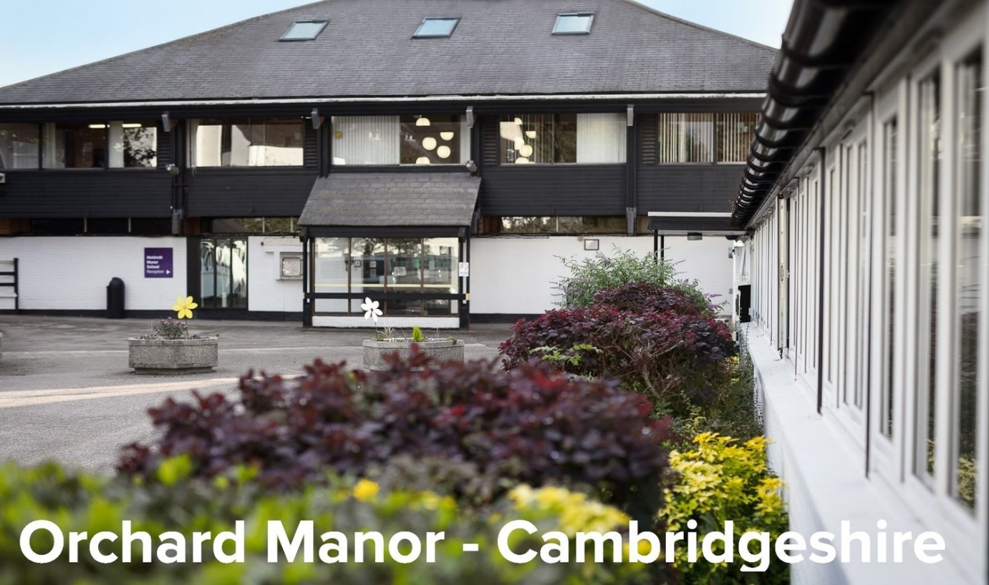

Contents

- Central Aims and Philosophy
- The Home
- Social Life
- Learning
- Safeguarding
- Choice, Capacity and Communication
- Religious Instruction and Observance
- Health and Welfare
- Positive Behaviour Management
- Staffing
- Complaints
- Missing Persons
- Fire Procedures and Health and Safety
- Admissions Policy
- Contact Details and Map

1. Central Aims and Philosophy
Aurora Orchard Manor is a purpose built Transition Service in the village of Meldreth, Cambridgeshire; 10 miles south of Cambridge and 4 miles north of Royston, set within c12 acres of land. There are open grassed areas, gardens, hard court areas, playgrounds and a sensory garden. The site is shared with Meldreth Manor School and Children’s Home.

We are registered with CQC as a Care home service without nursing to provide Accommodation for persons who require nursing or personal care
for Adults 18-65 (although we have an upper age limit of 30) with Sensory impairment, Physical disability, Learning difficulties or autistic spectrum disorder

The home is based around a person-centred approach whereby the residents are actively encouraged to be self-determining individuals with high self-esteem and voices that genuinely influence their lives, aims to be a place where people can have fun, make friends, and live an interesting and fulfilling life.

Effective, meaningful communication and participation is central to the philosophy of the home and all staff members are trained in a wide variety of augmentative and alternative communication methods and practices such as Makaton and Intensive Interaction.

Our philosophy of care is that planning for development starts from the needs of the individual. We seek to support each young person to develop his or her communication and physical skills, together with their individual levels of awareness, self-esteem and personal autonomy, so as to facilitate learning and improve their present and future quality of life.

In order to achieve this, we recognise that promoting the health, emotional and social wellbeing of each person is fundamental to their capacity to develop.

2. The Home
The home comprises seven self-contained flats, varying in size from 10 bedded to
single occupancy and each has its own staff team.

All accommodation is comprised of large communal dining and sitting areas with kitchens. Some kitchens are adapted with adjustable hobs and work surfaces. Overhead hoist tracking is in place where required. Each person has their own single bedroom with a well-equipped en-suite bathroom. Bedrooms are personalised to reflect individual particular likes and needs. People are encouraged to choose wall colour, posters, soft furnishings or any other touches to make their room their own. Each bedroom and bathroom has a custom-made call system, which is voice/sound activated. This enables young people to call for help/assistance. The system has a privacy aspect, and can be turned off if not required.

There is Wifi throughout and the Interactive Whiteboards in the Skills Development Centre are internet enabled.

Transport is available as appropriate to individual need and in line with risk assessments. It is used to take individuals to off-site activities, appointments or excursions.

The health, safety and well-being of individuals is safeguarded and assured through working in accordance with robust policies and procedures, in particular, safeguarding, health and safety, risk assessment, whistleblowing and complaints. All complaints are taken seriously, acknowledged, investigated and addressed within agreed timescales as per policy. All staff are trained re. the Compliments and Complaints Policy and copies are available to individuals, parents/ carers, authorities. Posters are displayed on staff and individuals' notice boards along with access details for the external, independent whistleblowing service.

Staff suitability checks are rigorous, including enhanced DBS, thorough employment and reference checking prior to appointment. All staff are supported to achieve relevant accreditation to ensure high levels of competence.
Individual financial risk assessments are completed, to check the level of support, if any, that may be needed to manage a person’s finances.

3. Social Life
At Orchard Manor we understand the importance of a healthy social network and encourage individuals to make new friends as well as maintain established relationships and family ties. Social, leisure, recreation, cultural and religious activities are available on and off site, e.g. bowling, swimming, riding, sailing, visits to the theatre, places of worship, cinema, pub, shops, social clubs or college courses. Guests and visitors are welcomed, in accordance with the wishes of individuals.

4. Learning
Learning new skills and developing independence is central to the Orchard Manor experience. The Skills Development Centre offers non-accredited learning opportunities. Sessions are led by Skills Tutors, who ensure that they are person-centred, interesting and engaging. Support staff work with individuals in the Skills Centre.

Some young people attend local colleges to access accredited learning.

5. Safeguarding
At Orchard Manor there is a fundamental belief that care and concern for each and every person, and respect for their human rights, is central to any caring community. Ensuring that the young people in our care feel safe and protected is of the utmost importance, and all staff are subject to extensive referencing and police checks before they begin working with us. Senior managers are Safer Recruitment trained and, before appointment, all staff members are required to undergo enhanced level DBS checks. This, together with rigorous recruitment and selection procedures, ensures that only those that are suitable to work with the individuals in our care are permitted to do so. Staff members initially start employment with a comprehensive four week induction programme. They complete a six month probationary period. Following successful completion of this, staff continue to receive regular supervision and appraisal. All staff work towards identified personal training goals. Ongoing development and reinforcement of skills and knowledge continues throughout their employment. Research is used to inform practice. This ensures that the most appropriate support programmes and interventions are used to achieve the best possible outcomes for each young person. All staff are trained in Safeguarding Adults and Children, in understanding the Mental Capacity Act, and Deprivation of Liberty Safeguards. There is an atmosphere of openness, cooperation and transparency and this includes working cooperatively with our commissioning teams and regulatory bodies.

All aspects of daily living activities are supported by robust risk assessment. This is on-going, and follows the comprehensive initial assessment of the individual’s needs and aspirations.

6. Choice, capacity and communication
All staff have training on the Mental Capacity Act and Deprivation of Liberty Safeguarding, and support plans include specific guidance on how to ensure that staff practice works towards each individual having as much control over their own life as possible. Support plans are updated regularly. Individuals exercise their rights, as members of the Orchard Manor community, by ensuring they have a ‘voice’ (through our total communication environment).

Those living at Orchard Manor contribute to how the service is run by attending regular meetings in the flat (between young people and staff) whereby aspects of the provision can be discussed. Keyworkers support individuals to express their needs, wishes, and concerns. Referrals for advocacy are made when required.

7. Religious Instruction and Observance
We recognise the importance of multiple faiths and staff work with people to ensure that their spiritual and cultural needs are met.

8. Health and Welfare
All people who use Orchard Manor services have a robust Care Plan in place. Information is gathered from the point of first contact. It comes from parents, prior support staff, teachers, social workers etc. and, importantly, from the young person themselves. Orchard Manor staff make observations across all relevant settings. The service therapists meet each person and complete a thorough assessment of their needs and requirements. The information gathered is compiled into an initial report, and is used as the basis for the person-centred Care Plan. This ensures that the Care Plan includes all the information required. It is updated and added to throughout the transition, in the early days of the placement, and during the time that the person spends at the service.

To look after the health needs of the young people, we use local GP, dentistry and optician services that have longstanding relationships with Orchard Manor. Each person has the option to choose other services if they wish. Each person has a Healthcare Plan and Hospital Passport. These outline important health information such as history, allergies, conditions, and any regular medication. They also include communication guidance.

Management of medication administration and clinical tasks, such as, gastrostomy, oxygen therapy and suction to support complex health needs are delegated by relevant health professionals to suitably trained and supervised staff members.

Medication is ordered electronically. Medication is delivered by the courier and is booked into the service by medication trained staff. It is stored safely and appropriately re. temperature and access. Medication is administered by trained staff, as prescribed.

Therapy
Therapeutic and clinical input includes physiotherapy, occupational therapy, and speech and language therapy. Hydrotherapy, and rebound therapy take place onsite, delivered by suitably trained staff.

The Speech and Language Therapist provides training and guidance so that staff are able to fully support people with a diverse range of communication needs. We are able to devise social stories, update communication books and support people with PECs. Makaton sign language is used throughout the service and people are supported to use their own preferred communication methods. Some people use iPads and tablets as communication and leisure tools (including for communication with family members).

We support people to identify where assistive technology may be of benefit and to practice its use in a safe and supportive environment. Support to obtain funding for equipment is provided.

Following an initial assessment by a physiotherapist, each individual will be provided with an individual physical programme. This is then incorporated into their individual care plans and will be delivered as appropriate by members of the inter-disciplinary team having been trained and deemed competent to carry out the task.

The physiotherapist will monitor each person’s physical progress and will revise and update their individual programme as appropriate.

The programme may include some or all of the following depending on the individual need:-

- 24 hour Postural Management (see equipment checklist)
- Passive Stretches
- Group/Individual Exercise Sessions
- Hydrotherapy
- Rebound Therapy
- Cycling

Diet and Nutrition
The Speech and Language Therapist makes a thorough assessment of each person’s eating and drinking needs. They complete an Eating and Drinking Plan for staff to follow, trains staff initially, and supports staff competency.

All nutrition choices, dietary, religious or cultural needs are respected and provided for. Involvement in menu-planning shopping and meal preparation is promoted and supported.

There is a central catering team on site, providing balanced and nutritious menus.

Personal Care
Personal care needs are assessed prior to placements being agreed. Appropriate staffing models are implemented, and costed accordingly. The bathrooms offer flexible fittings, to accommodate a range of needs. Privacy and dignity is maintained at all times. Each person has a personal care plan, which outlines all needs. Learning objectives are agreed with the young person, family and social worker.

9. Positive Behaviour Management and Challenging Behaviour

At Orchard Manor, staff are trained in the Positive Behaviour Support (PBS) and BILD accredited behaviour management technique ‘PRICE’ (Protecting Rights in a Caring Environment). Staff are also trained in Intensive Interaction, and understanding the communication needs of people with complex needs. The purpose of the package of training is to give staff the skills to recognise and respond to each individual’s communication in a way that promotes positive interactions.

Each person who presents with behaviour that may challenge others will have a comprehensive risk assessment and an agreed positive behaviour management plan. This will include primary and secondary strategies. Wherever possible, the person will be involved in the planning and review processes.

10. Staffing
The overall structure of staffing within the service is outlined below:

Registered Manager – Catherine Rundell
Cathy is the manager of Orchard Manor and is responsible for the overall running of the service. Cathy became registered manager in September 2016. Cathy has completed NVQ Level 5 in Leadership for Health and Social Care and Children and Young People’s Services - Adult Management (England).

There are four Care Managers overseeing the staff teams. Team Leaders work closely with Senior Support Workers and Support Workers to provide 24-hour care and support to individuals. Staffing ratios are agreed initially at transition and reassessed if needed.
The Care Managers and Team Leaders have substantial experience of working within care, and have additional training in management of staff and the management role to enable them to support their teams to provide the highest standards of provision in a progressive and adaptable environment.

The Registered Manager provides line-management to the Physiotherapist, Speech and Language Therapist, Occupational Therapist, Care Managers and Skills Tutors.

Training
Orchard Manor provides a comprehensive induction package, which includes a rolling programme of refresher training and encourages staff to undertake extra courses to extend their skills and understanding. The standard induction training includes the following areas:

- Safeguarding Adults
- Mental Capacity
- Deprivation of Liberty Safeguarding
- PRICE behaviour management
- Autism awareness / Epilepsy awareness
- Food Hygiene
- Postural management
- Augmentative and Alternative Communication
- Enteral Feeding
- Recording and Reporting
- Supporting in a Learning Environment
- Eating and Drinking
- Physiotherapy and Complex Needs
- Fire Safety / Health & Safety / Manual handling / First Aid

Supervisions, Appraisals and Support
All staff receive supervisions from their line-manager, the Registered Manager or a designated senior member of staff regularly, with more frequent supervisions for newer members of staff or upon request. The supervision process includes competency assessments and observations of practice. Supervisions take place in a 'formal' 1:1 setting and are confidential. Experienced staff are encouraged to mentor throughout the day to ensure practice is kept to a high standard. All staff also receive an annual appraisal to acknowledge achievement and discuss how to further develop them, develop their practice, and maintain high standards.

11. COMPLAINTS
There is a comprehensive Complaints Procedure, which is time-bound, and includes formal and informal stages. Notice boards display who young people can make a complaint to, and staff are able to support them with this as required.

12. MISSING PERSONS
There is a Missing Persons Policy and Procedure in place and this is followed should it be needed.

13. FIRE PROCEDURES AND HEALTH AND SAFETY
Orchard Manor has a sophisticated L1 Fire Detection System and manual activation points. A sprinkler system is in use in the larger buildings. The system is tested weekly and serviced regularly. The fire staircases enable people to escape from the building. Regular evacuation drills are held in accordance with requirements, and our fire evacuation procedure. There is a comprehensive fire risk assessment in place. All staff are trained in fire prevention and evacuation.

Each person has a comprehensive risk assessment and PEEP in place. These detail evacuation procedures and any specific risks regarding issues such as mobility, noise sensitivity, likelihood of compliance and equipment required etc. All staff must read and sign these risk assessments as part of their induction.

We comply with all relevant fire and building regulations/legislation.

Regular checks on all equipment are undertaken including PAT testing, fire extinguisher testing, bi-annual checks of emergency lighting via an external body, (weekly checks are also undertaken in-house), and weekly checks of the alarms, fire doors and emergency equipment (such as fire blankets, torches etc.) are undertaken by senior staff.

Where buildings are serviced by gas, there are carbon monoxide monitors installed and awareness posters are in place. During induction training staff are made aware of the signs and symptoms of carbon monoxide poisoning.
.

14. ADMISSIONS, DISCHARGE AND FEES
Referrals can be made by social workers/health workers. Visits from any of these parties, and of course potential service users and their parents/carers, are welcomed by appointment. If it is felt that Orchard Manor could be a suitable placement for an individual, assessments are arranged via the Registered Manager. Final decisions about an offer of a place are based on the ability of Orchard Manor to meet the person's needs, and compatibility with current residents. Fees are based on individual needs and agreed between Orchard Manor and the placing authority prior to admission.

15. CONTACT DETAILS AND MAP

Provider: Company Office
Aurora Meldreth Limited
Unit 13 Twigworth Court Business Centre
Tewkesbury Road, Twigworth
Gloucester
GL9 2PG

02306 170170 enquiries@the-aurora-group.com

Registered Manager & Location address:

Catherine Rundell
Orchard Manor
Manor Road
Meldreth
Royston
Hertfordshire
SG8 6LG

01763 268000

